

**COMPUTER SCIENCE**

**ENGINEERING**

**MUSIC PLAYER**

SUBMITTED TO:

MR. SAGAR PANDE

SUBMITTED BY:

VRINDA AGGARWAL(11910042)

DEEPANSHU SINGLA(11910044)

ARYAN SHARMA(11910050)

Summary:

This project is for playing any type of audio format specially for playing music. It consists of all keyfeatures that music player must have like import music or any other audio file from your PC, Playing or pausing that audio file , You can increase and decrease volume as per you level. We have also added some special features like customize theme and import whole folder in your music player.

Acknowledgement:

I would like to express my special thanks of gratitude to our beloved professor Mr. Sagar Pande , Department of CSE , Lovely Professional University,Punjab who gave us the opportunity and give their fruitful guidance and suggestions to complete this project . Me and my teammates together completed this project and we all three have nearly equal contribution for making this project successful. As a team leader I consistently guided my teammates.

Table of contents

* Introduction
* Contribution
* Installation Requirements
* References
* Features
* Advantage of Python
* Conclusion

Introduction:

The main objective of this project is to design cross-platform media player using python and tkinter . Python Is Really Very Interesting Language because this language provides usability to write cross-platform codes that can run on all types of the system without even doing any big changes in codes. This Python module provides a high-level core Music player interface where you are supposed to provide all the remaining high-level logic like the user interface, the playlist logic and the audio data

Contribution:

VRINDA: worked with the progressbars and its functionality, functionality of menubar, worked with pygame module

DEEPANSHU: designing and placing of buttons and worked with the button images and background images, created menubar

ARYAN: designing frames, colours, listbox, song labels and track status, worked with pygame module

Installation Requirements:

* Mutagen
* Pygame
* Ttkthemes
* Os
* Datetime
* Tkinter

References:

* <https://docs.python.org/3.2/library/datetime.html>
* <https://www.pygame.org/docs/ref/music.html>
* <https://www.tutorialspoint.com/python/tk_label.htm>
* <https://mutagen.readthedocs.io/en/latest/api/mp3.html>

Features:

* Import audio file
* Play or pause Music
* Increase or decrease volume

Special features :

* You can customize theme according to your music taste and mood like dark , light and default theme and can enjoy your music
* You can import your whole music folder in this music player as you can select/play/pause directly from music player

Our Different Themes:

(Light)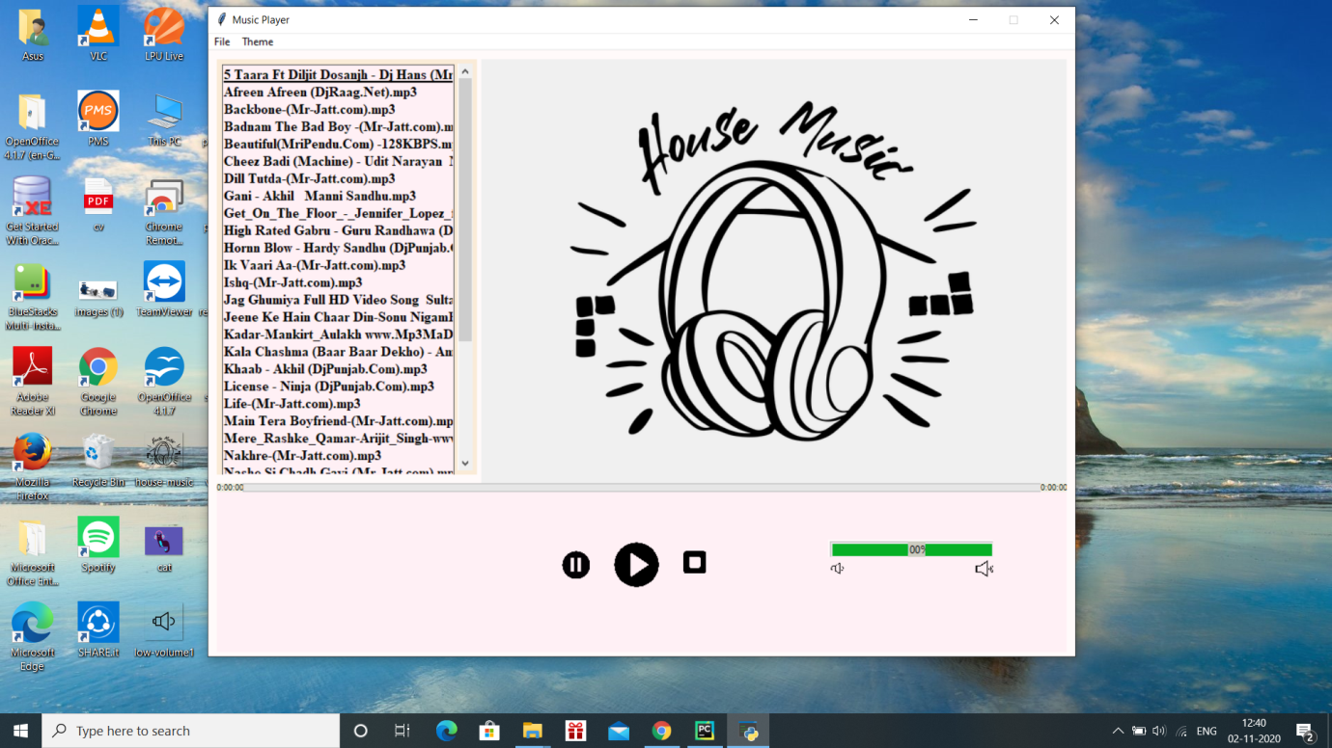

(Default) 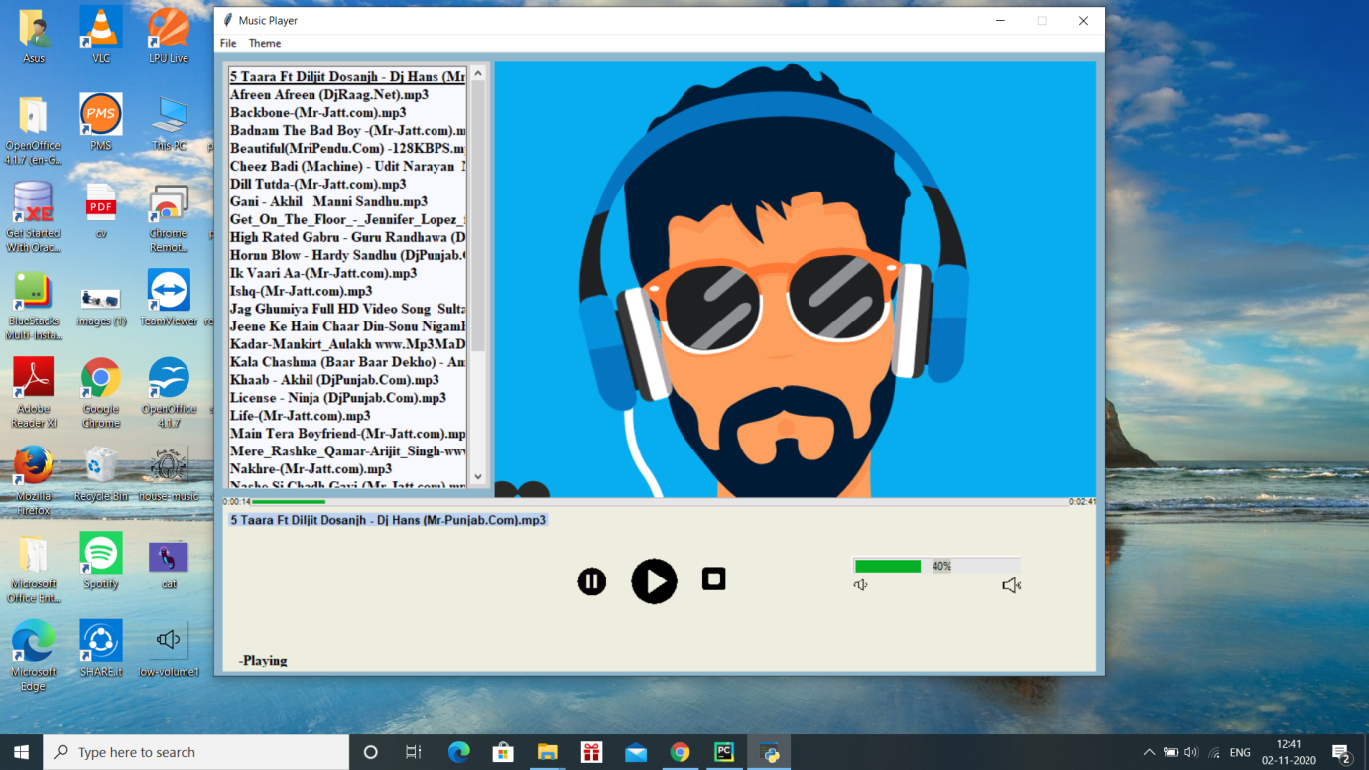

(Dark)

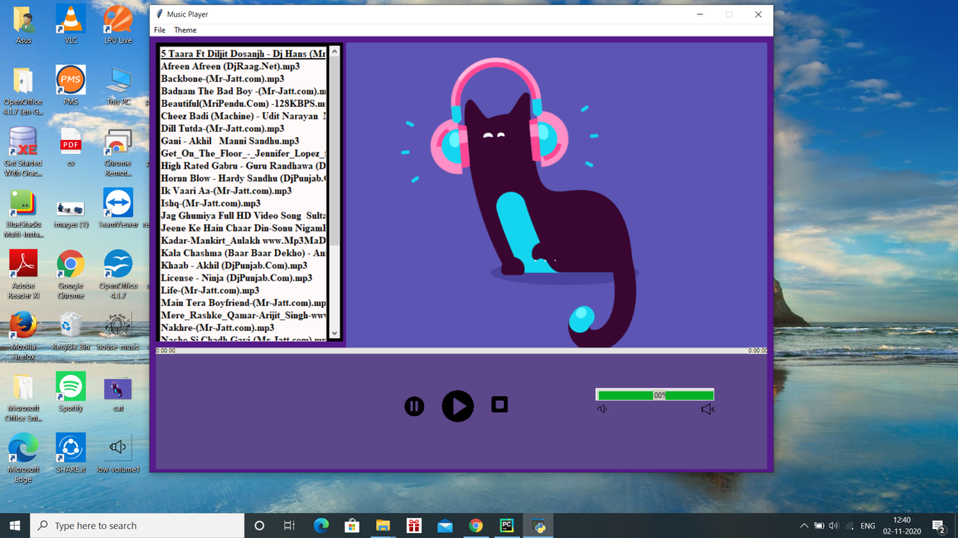

Advantage of python:

User-friendly Data Structures:

Python has built-in list and dictionary data structures which can be used to construct fast runtime data structures. Further, Python also provides the option of dynamic high-level data typing which reduces the length of support code that is needed.

Conclusion:

As we designed this music player specially for music lovers as can customize theme according to their moods and can listen their favourite playlist at one go. We designed it in such a way that it can be used by any user and can play any audio files that he/she wants to listen. We try our best to give immersive and user friendly experience to the user .